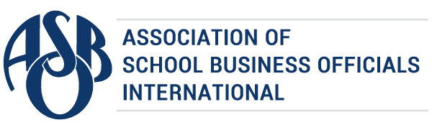

The Certificate of Excellence in Financial Reporting
is presented to

Dayton City School District

for its Annual Comprehensive Financial Report
for the Fiscal Year Ended June 30, 2021.
The district report meets the criteria established for
ASBO International’s Certificate of Excellence in Financial Reporting.
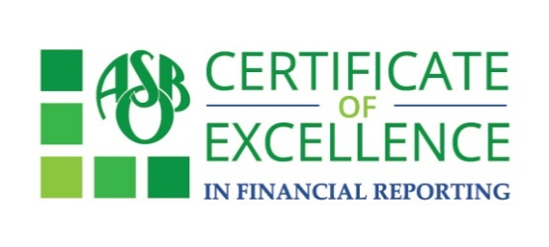

William A. Sutter David J. Lewis
President Executive Director

