Nutrition Services Department
Rosa Parks Breakfast March 2024 Menu
Monday | Tuesday | Wednesday | Thursday | Friday
 |  |  |  | 1
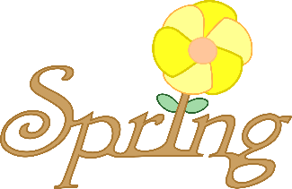 |  |  |  | WG Blueberry Mini Loaf  Banana  Milk
4 | 5 | 6 | 7 | 8
WG Cinnamon Toast Crunch  Diced Pears  Milk | Yogurt and WG Goldfish Graham  Tropical Fruit Salad  Milk | Banana Bread  Fruit Cocktail  Milk | WG Mini French Toast  Apple Quarters  Milk | WG Blueberry Muffin  Fresh Banana  Milk
11 | 12 | 13 | 14 | 15
WG Rice Chex  Chilled Pears  Milk | WG Mini French Toast  Serve at Room Temp or place in warming cart  Mixed Fruit  Milk | WG Strawberry Mini Bagels  Pineapple Tidbits  Milk | WG Blueberry Muffin  Applesauce  Milk | Apple Cinnamon Texas Toast  Fresh Banana  Milk
18 | 19 | 20 First Day of Spring | 21 | 22
WG Cheerios  Tropical Fruit  Milk | WG Cin Raisin Bagel with Cream Cheese  Mixed Fruit  Milk | WG Mini Pancakes  Fresh Apple Quarters  Milk | WG Strawberry Yogurt Chex Mix Diced pears  Milk | WG Mini Blueberry Loaf  Fresh Banana  Milk
25 | 26 | 27 | 28 | 29 Good Friday
Spring Break | Spring Break | Spring Break | Spring Break | Spring Break
* This item may contain pork.
ALL MENUS ARE SUBJECT TO CHANGE WITHOUT NOTICE
This institution is an equal opportunity provider.

